**Overview**

Follow these instructions to access the Programming Assignments on GitLab.

By default you should have access to these repositories:

* <https://gitlab.textdata.org/cs410-fa17/MP1>
* <https://gitlab.textdata.org/cs410-fa17/MP2>
* <https://gitlab.textdata.org/cs410-fa17/MP3>

**You should complete MP 1 by Sunday of Week 3.**

We will try to setup MP2 as an example, but keep in mind that the procedure is the same for MP1 and MP3:

1. Click on **Fork.**

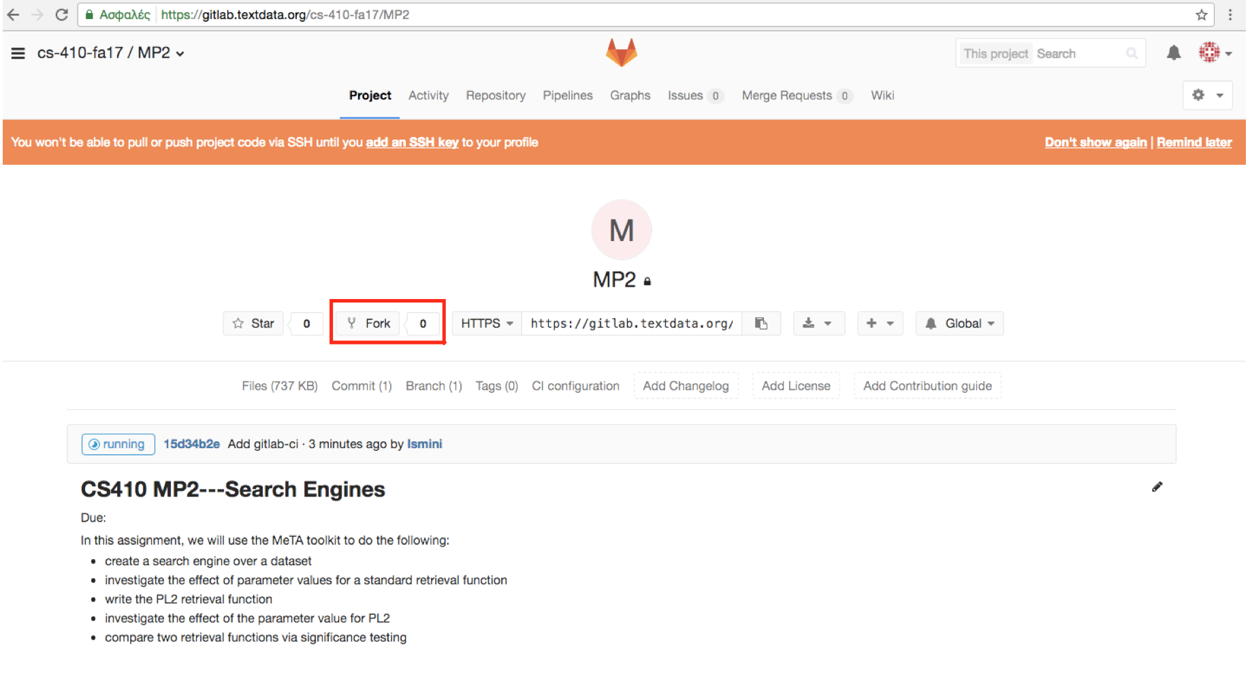

2. Click on your username.

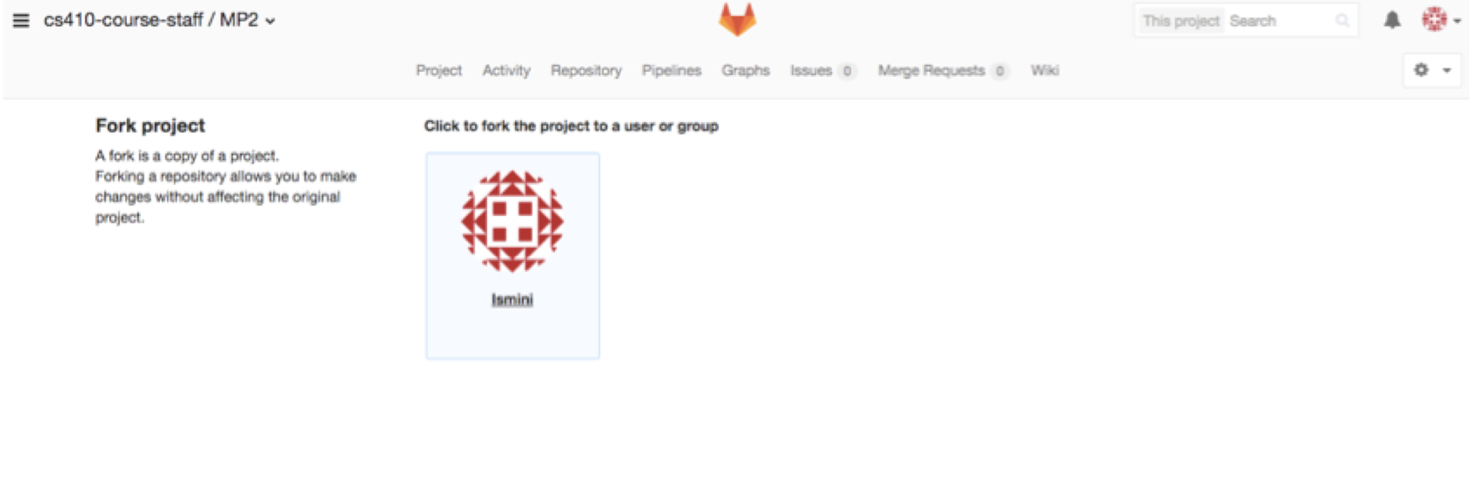

3. After forking the project, you should have MP2 on your personal projects.

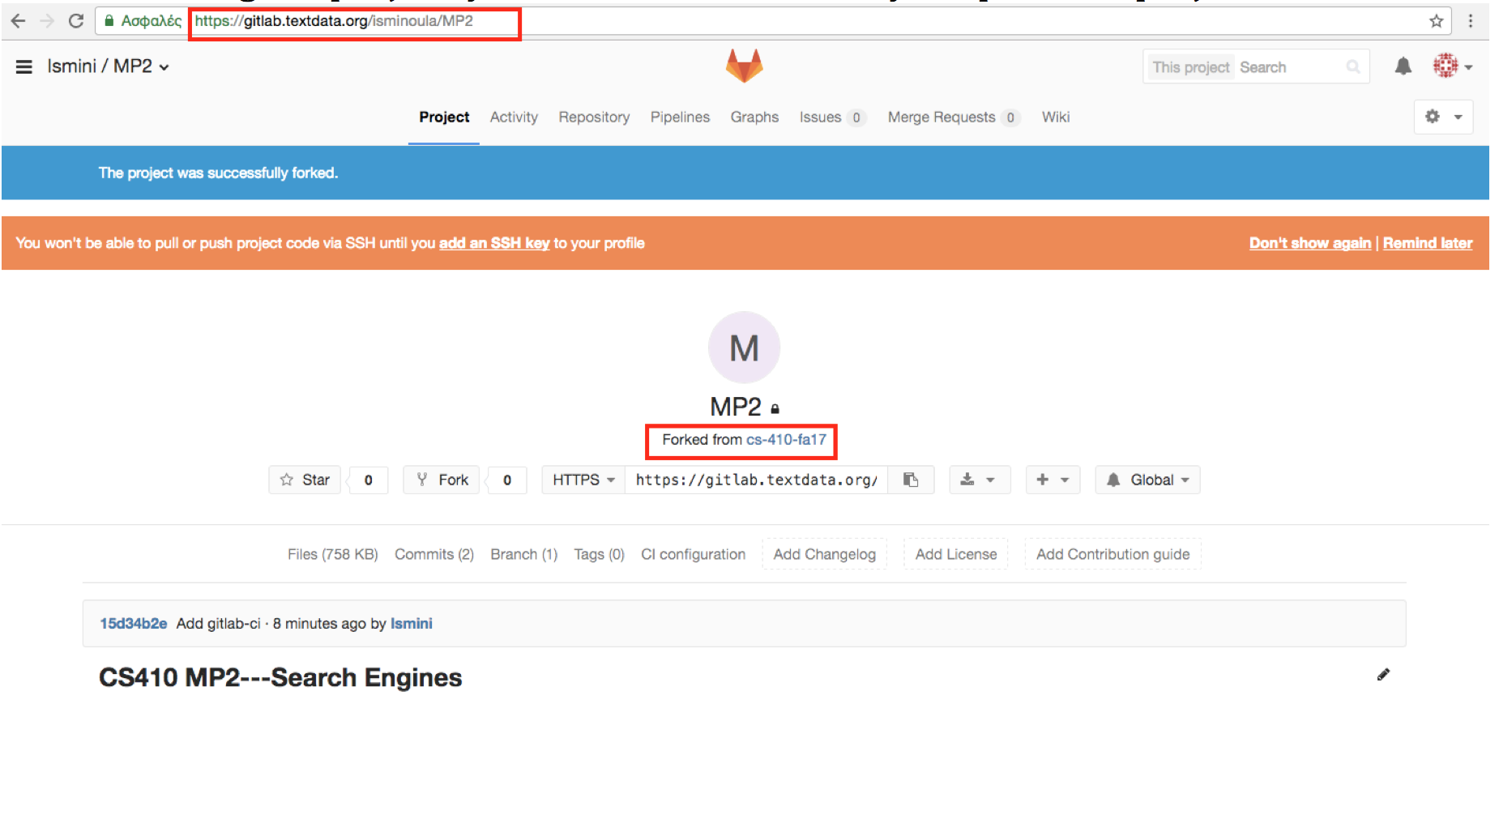

4. Go to **Account Settings.**

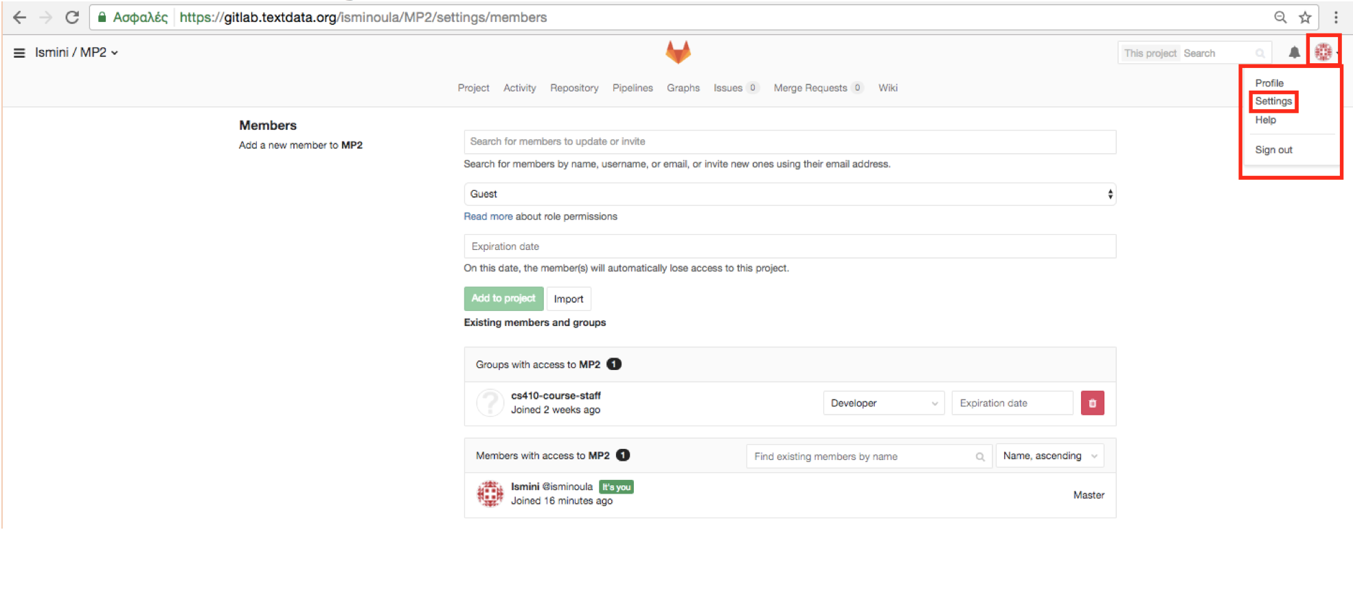

5. Click on “**Access Tokens**”.

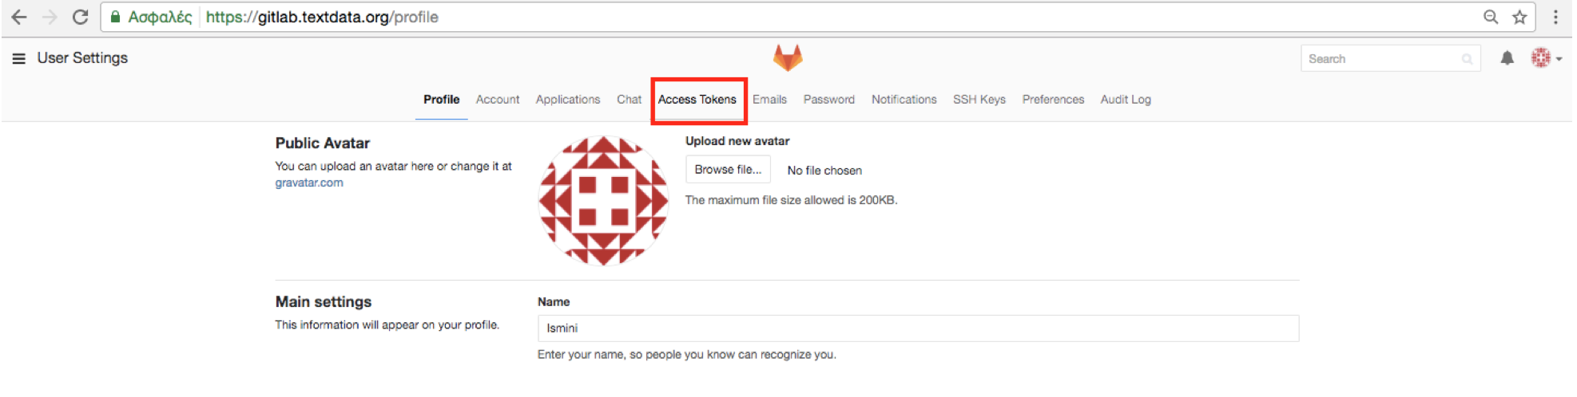

6. Add **GITLAB_API_TOKEN** as the name for the token and select **“Read user information”.** Press the button **Create Personal Access Token.**

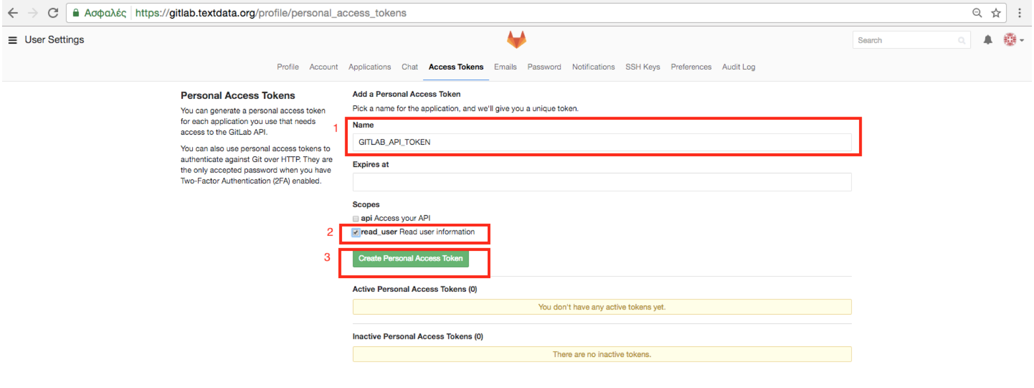

7. Copy the token, we will need this for the next steps.

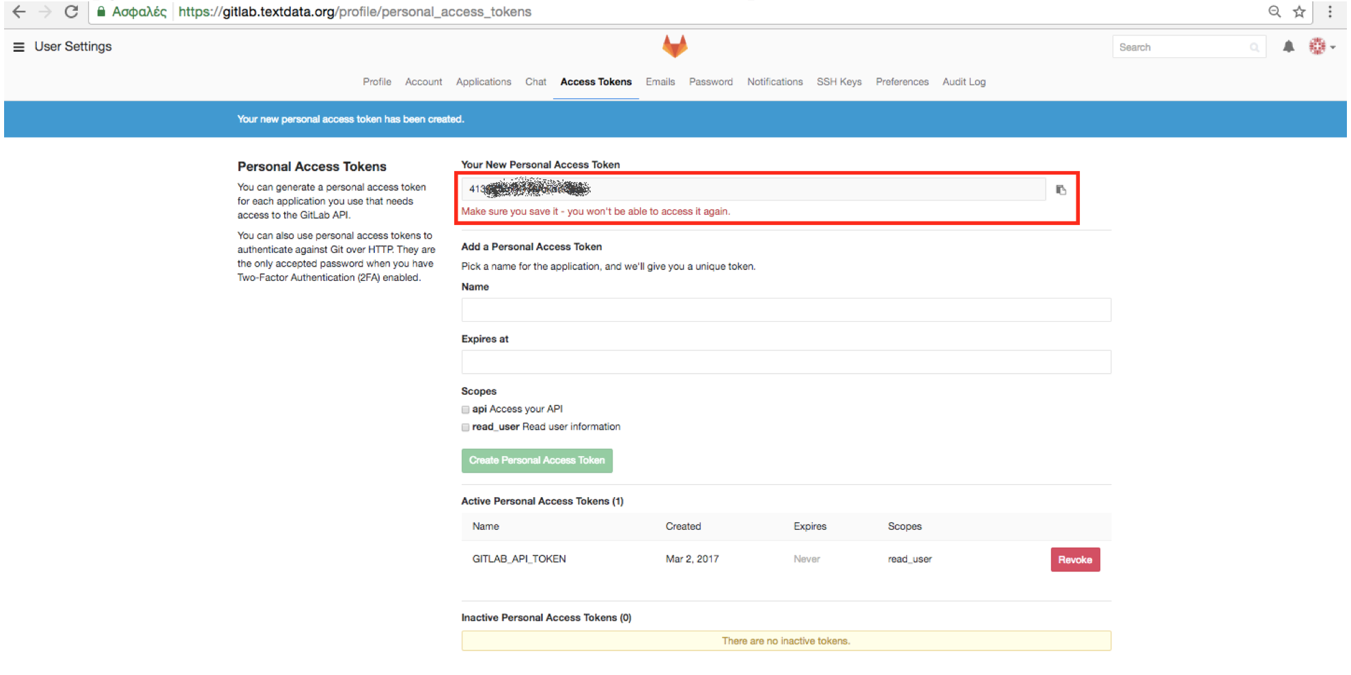

8.From the project **Settings** go to **Pipelines**

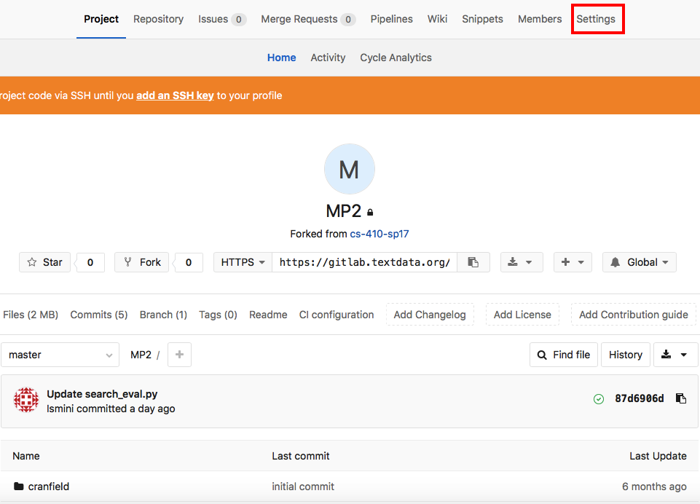

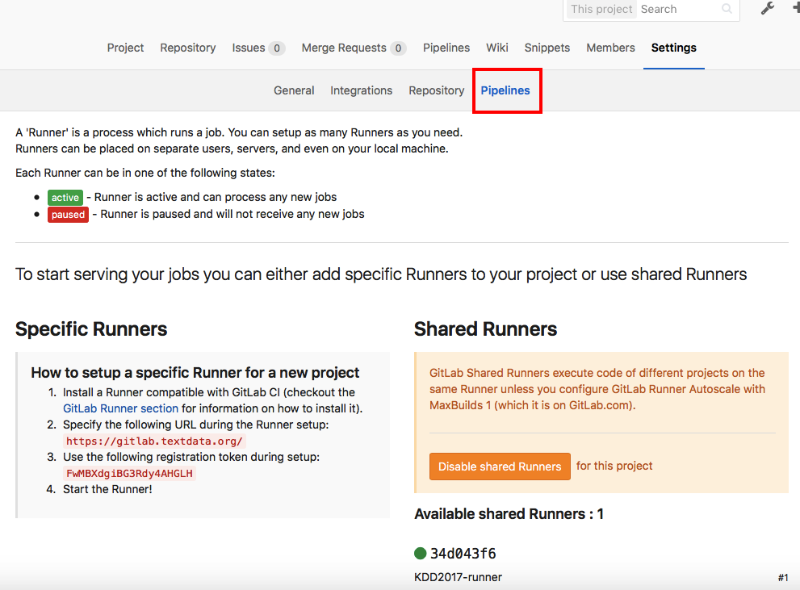

9. Add a variable with name **GITLAB_API_TOKEN** and the value the personal access token copied at step 7. Click on **Add new variable.**

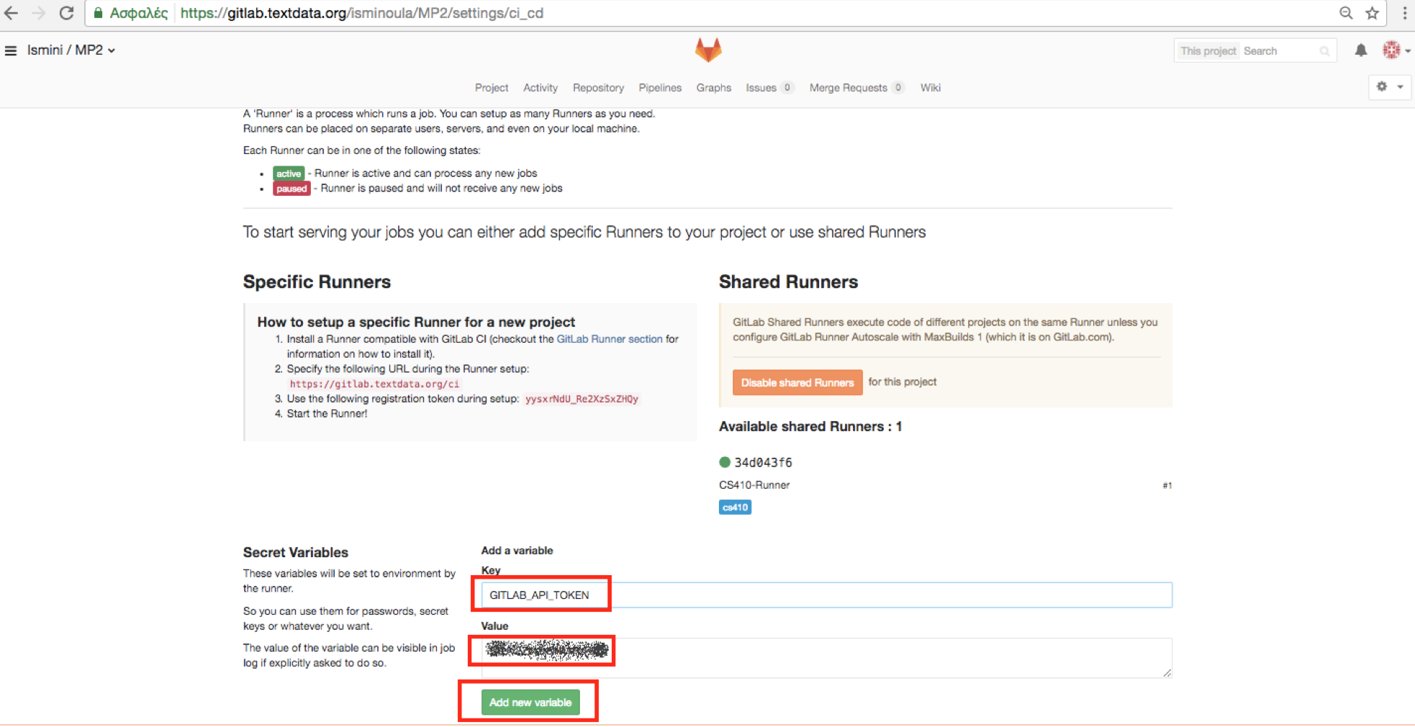

10. Add a variable with name **COMPETITION_ALIAS** and the username you would be displayed in the leaderboard results. Click on **Add new variable.**

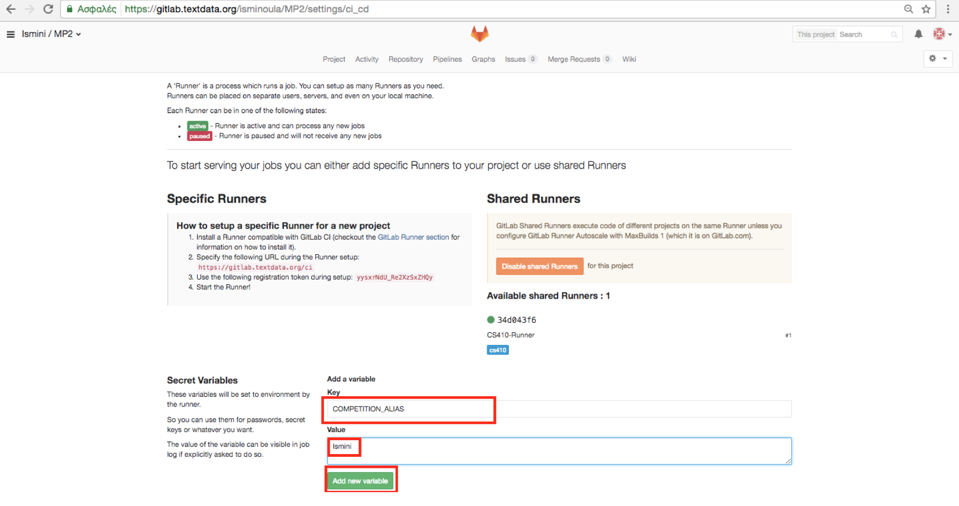

**You are all set!**

Every time you edit a python script, you can see the test running by clicking Pipelines. Once finished, it will tell you whether your code passed the tests (Succeeded) or not (Failed).

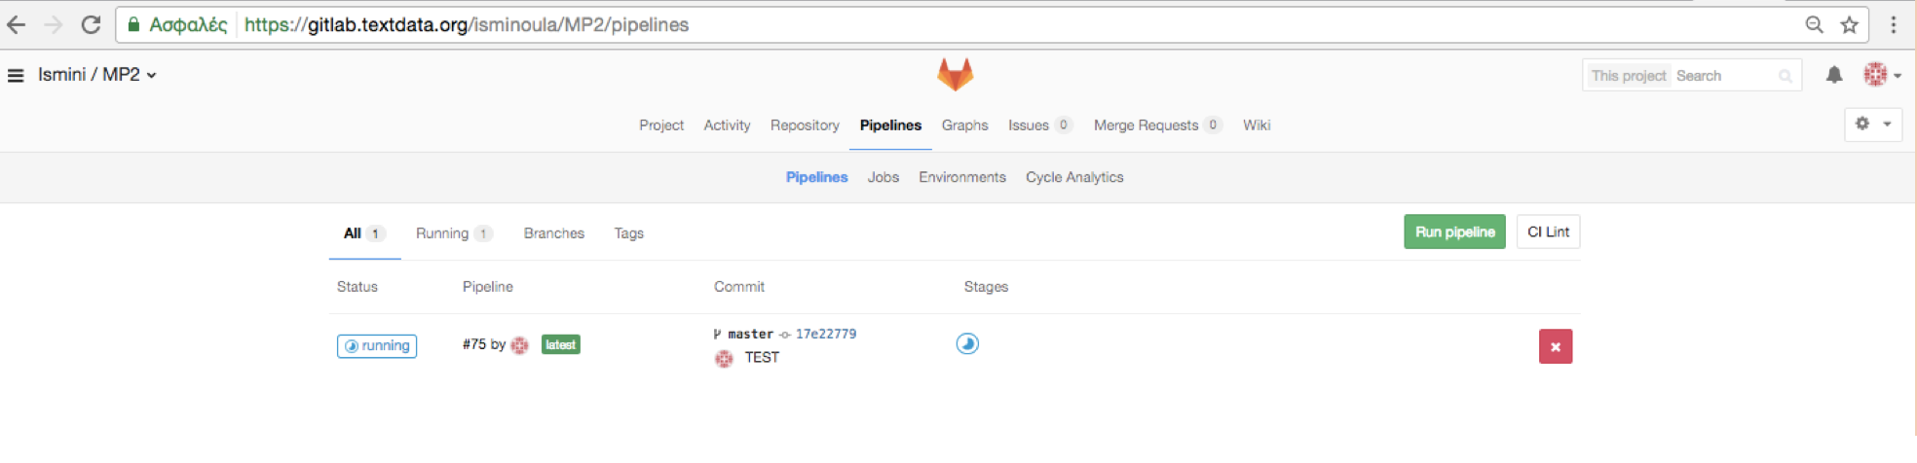

Below is an example of a failed test, where you can read the error like you would on command line:

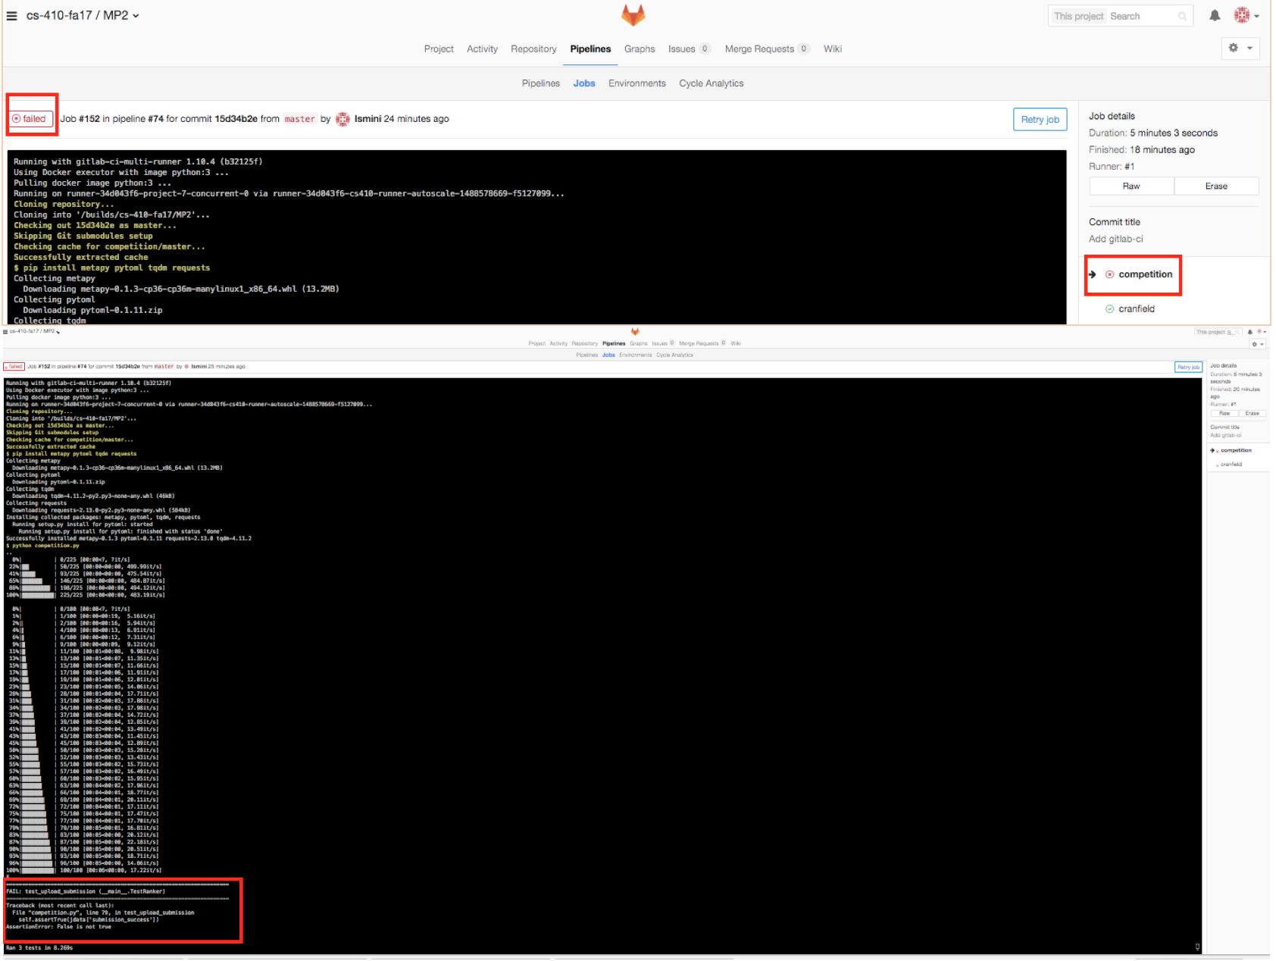

And an example of a passed test:

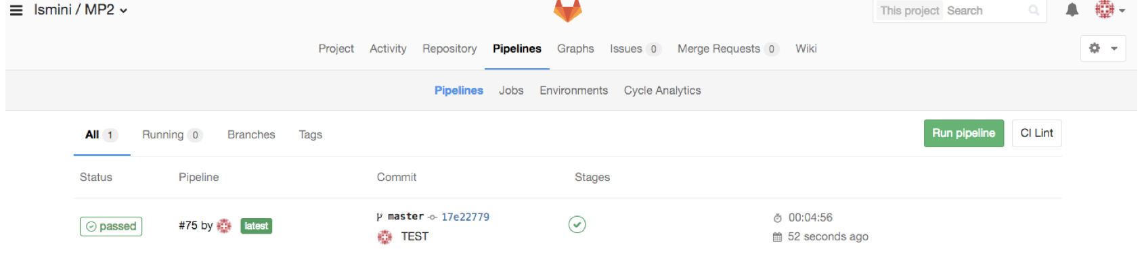

**May all your tests be passed! Have fun!**